**Power BI Space Missions Analysis   
  
Overview:**

This Power BI project focuses on analyzing space missions data obtained from Maven Analytics. The dataset encompasses space missions from 1957 to August 2022, including details on launch location, date, mission result, responsible company, rocket name, price, and status. The analysis aims to derive insights into the trends of rocket launches over time, mission success rates, successful countries, frequently used rockets, and launch location patterns.

**Objectives:**

1. Understand the trend of rocket launches over time and assess the increase in mission success rates.
2. Identify countries with the most successful space missions and observe historical trends.
3. Determine the most frequently used rockets and ascertain their current activity status.
4. Analyze launch location patterns to discern any noticeable trends.

**Data Analysis:**

Rocket Launch Trends over Time:

* Presented through a line chart, showcasing the number of rocket launches over the years.
* Analysis indicates any significant spikes or declines in launch activity.

Mission Success Rate by Company:

* Utilized a bar chart to display the count of successful missions by company.
* Identified CASC as the leading company with 233 successful missions.

Total Missions by Rockets:

* Represented using a bar chart, highlighting the total missions by rocket.
* Falcon 9 Block 5 emerged as the most frequently used rocket with 111 missions and still active.

Mission Status Distribution:

* Visualized using a donut chart, illustrating the distribution of missions by status.
* Noted that 94% of missions were successful, with 3% failure and 1% partial failure.

Launch Location Analysis:

* Identified Florida, USA, as the location with the most successful missions, totaling 146.
* Budget for these missions exceeded 53 billion dollars.

**Visualization:**

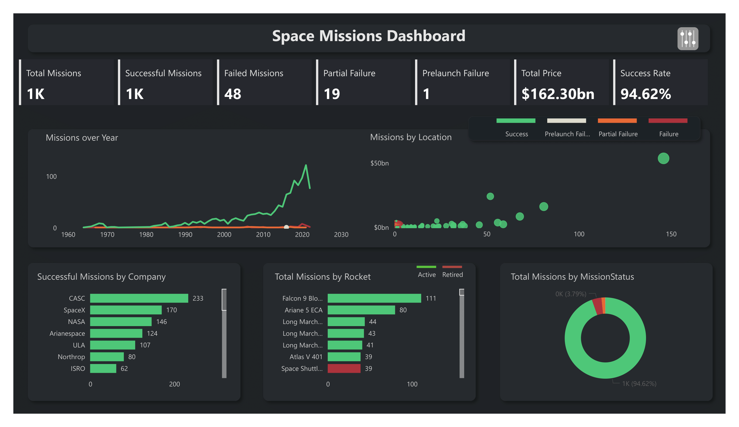

**Filters and Interactivity:**

* Implemented filter icons for year, company, location, mission status, rocket status, and mission options to enhance user interaction and exploration of the data.

**Key Metrics:**

* Incorporated cards displaying the count of total missions, successful missions, failed missions, partial failures, prelaunch failures, total price, and success rate. These metrics provide a quick overview of the dataset's key aspects.

**Insights:**

1. The year 2021 witnessed the highest number of successful rocket launches at 122, with minimal failures.
2. CASC of China stands out as the most successful company
3. Falcon 9 Block 5 emerges as the most frequently used and still active rocket.
4. Launches from Florida, USA, have been notably successful, indicating a significant investment in space exploration in the region.

**Conclusion:**

This Power BI analysis offers valuable insights into space mission trends, success rates, and key players in the industry. Through interactive visualizations and insightful metrics, stakeholders can gain a comprehensive understanding of historical and current space mission data.